FPGA系統設計實務

期末報告

M11102150

劉家瑜

Design

RTL

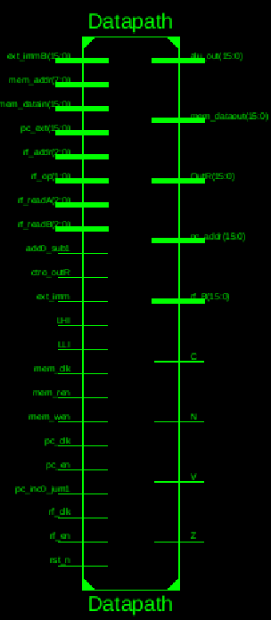 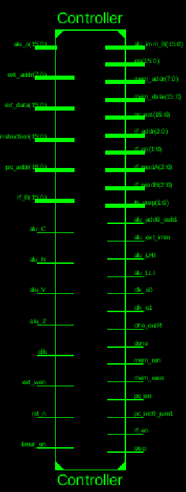 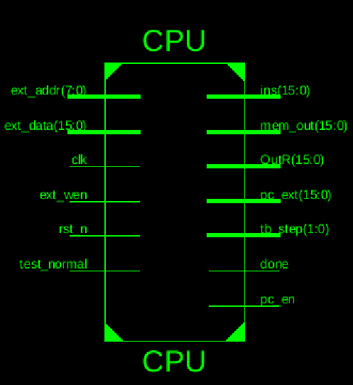

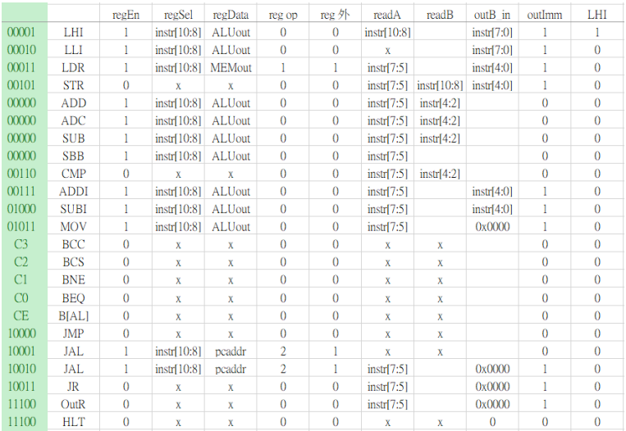

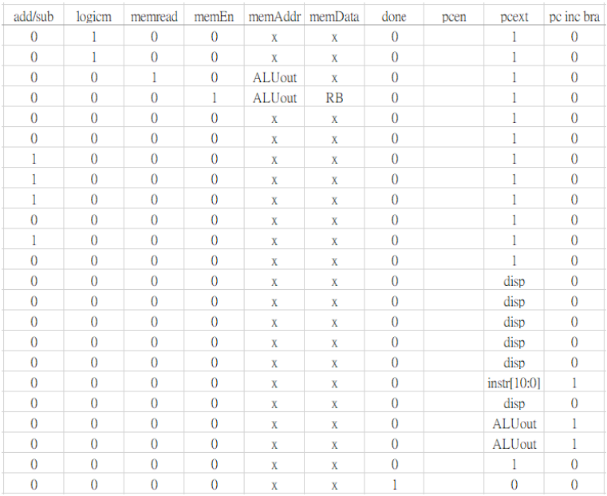

Datapath

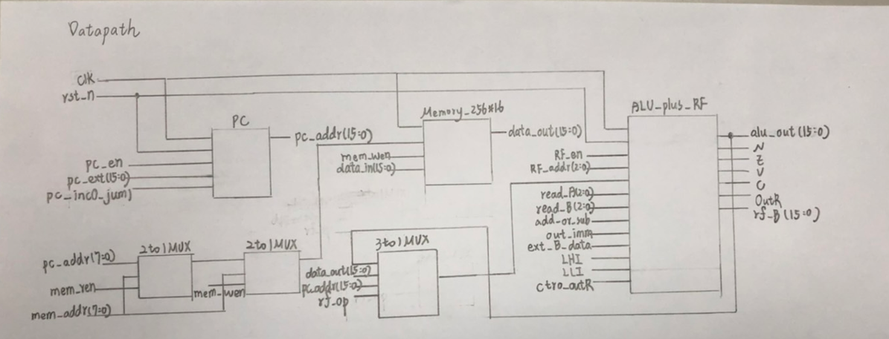

Verilog HDL

1. CPU

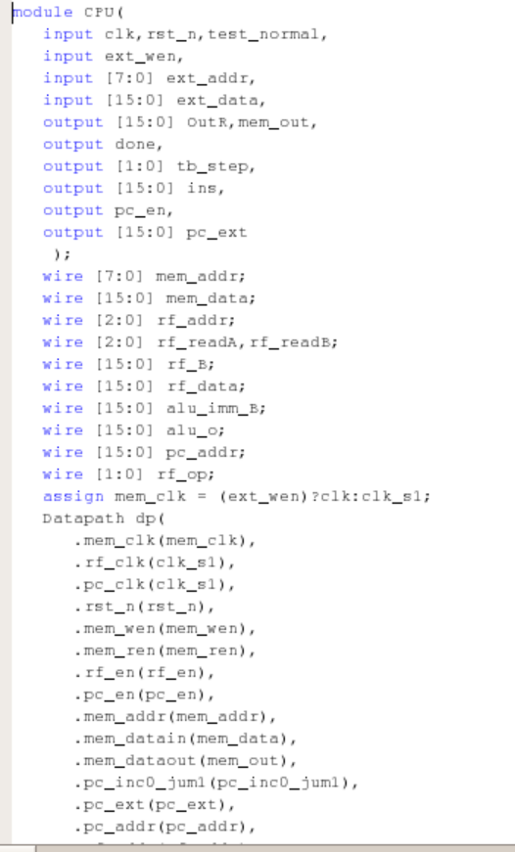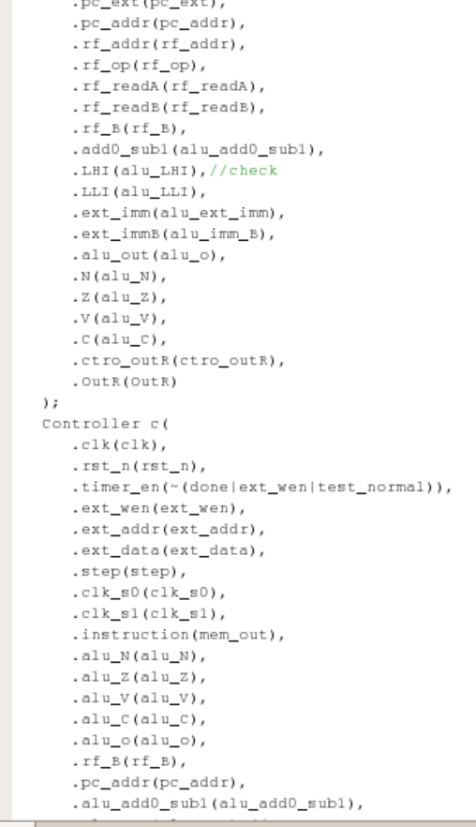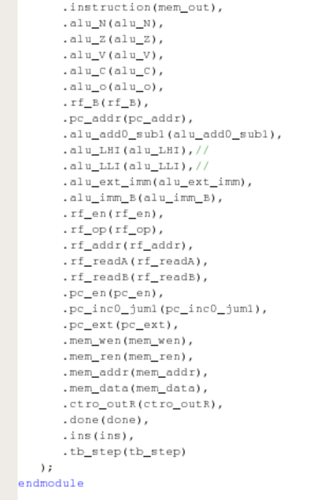

1. Controller

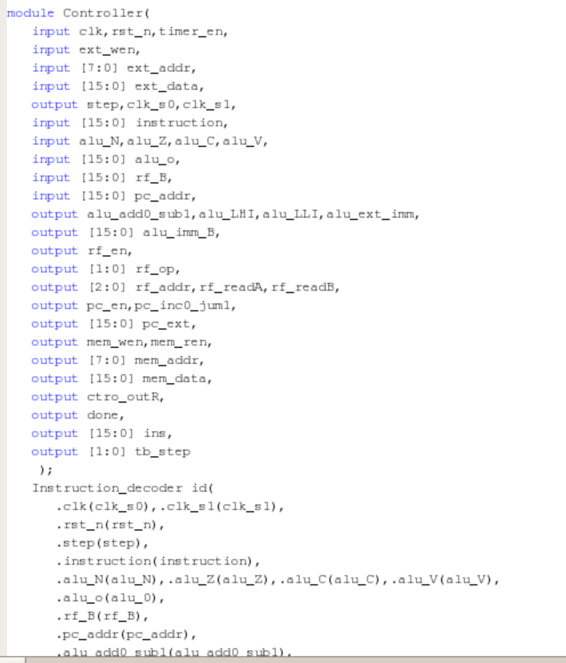

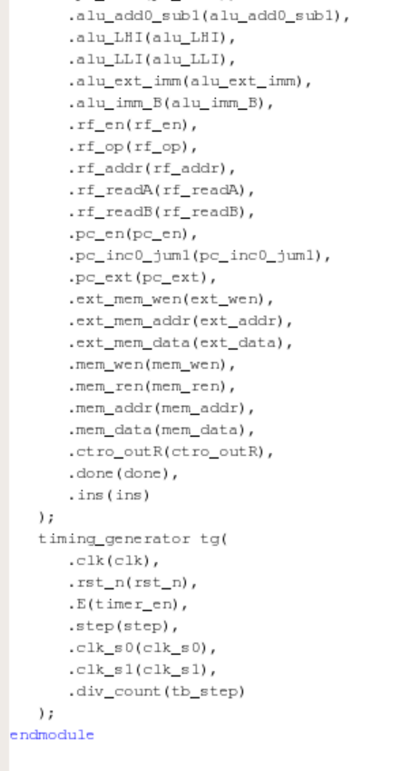

1. Datapath

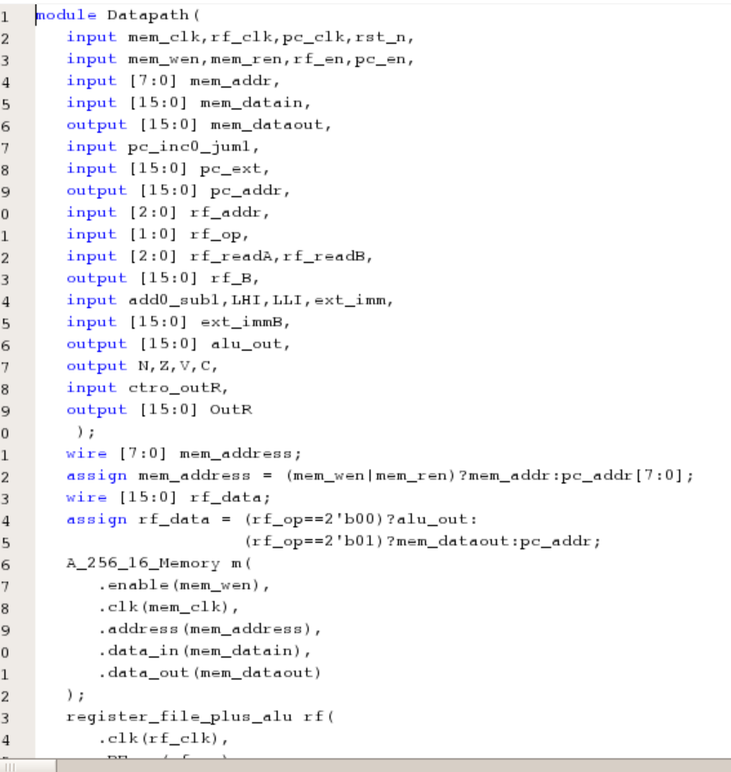

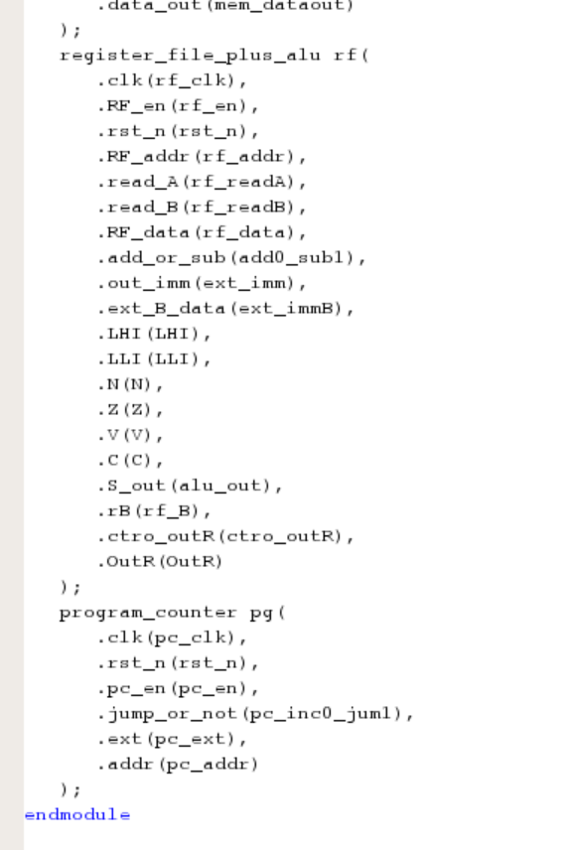

1. Instruction Decoder

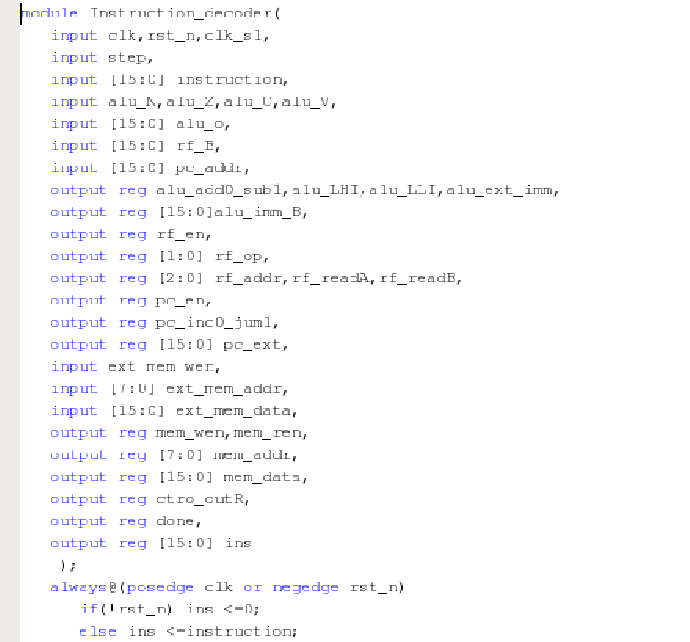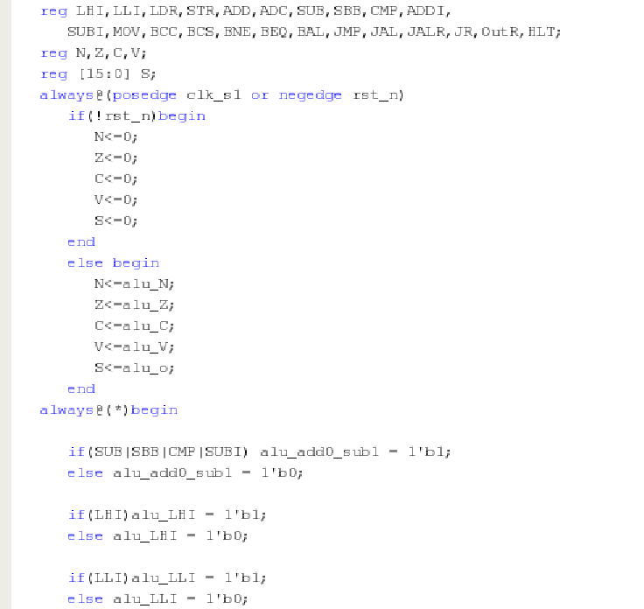

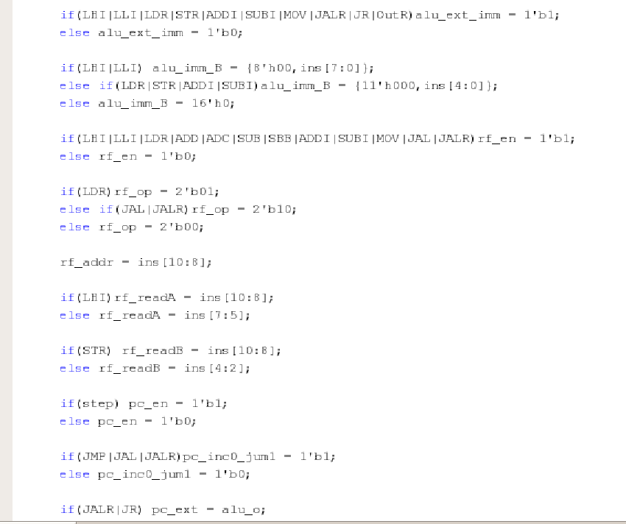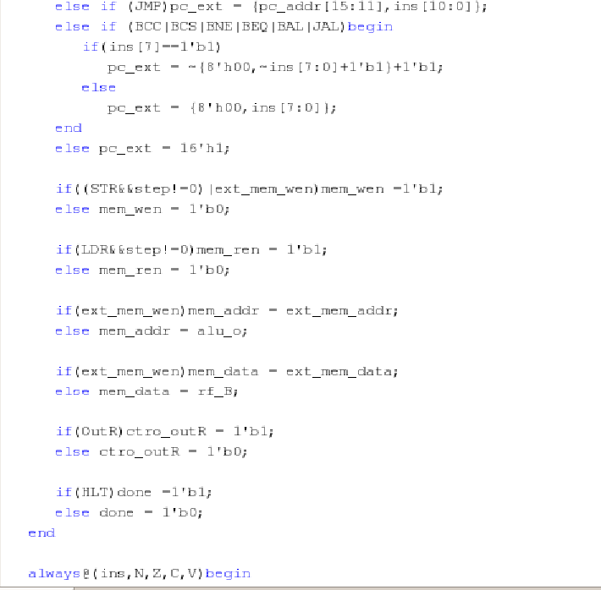

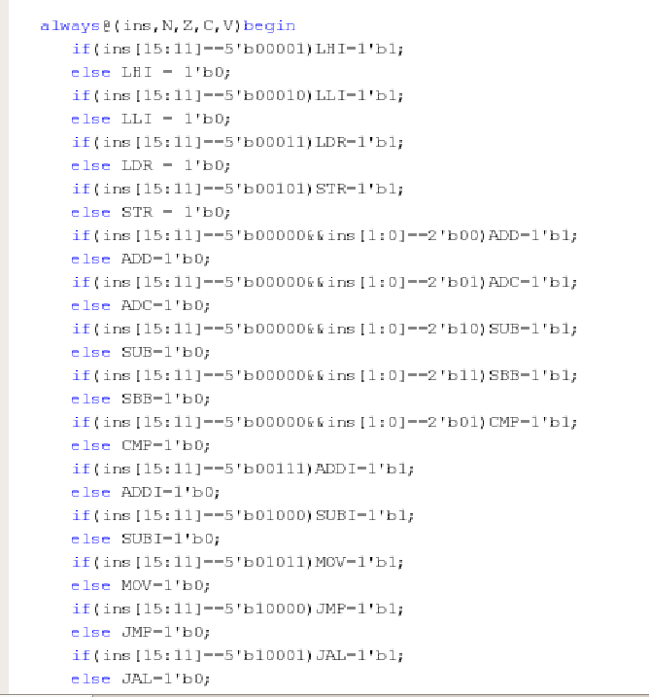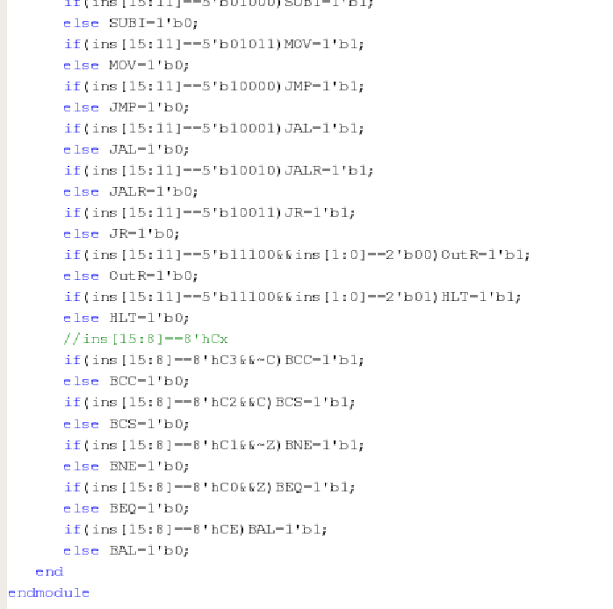

1. Timing Generator

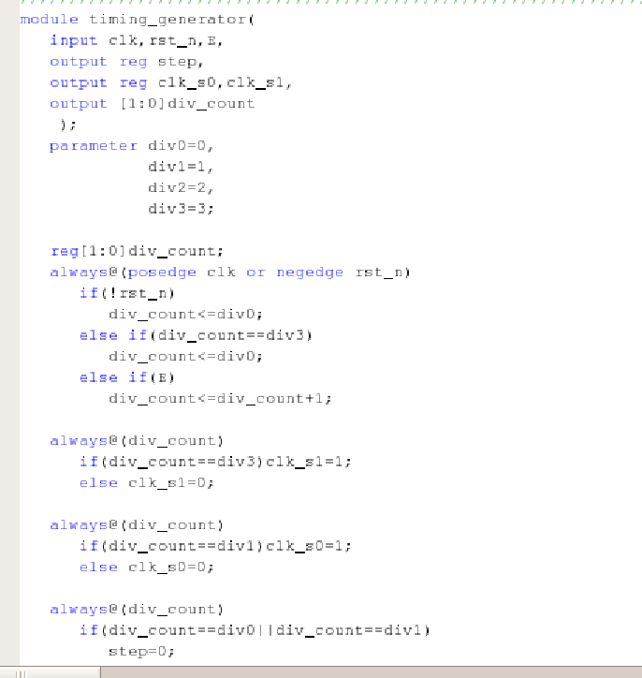

1. Program Counter

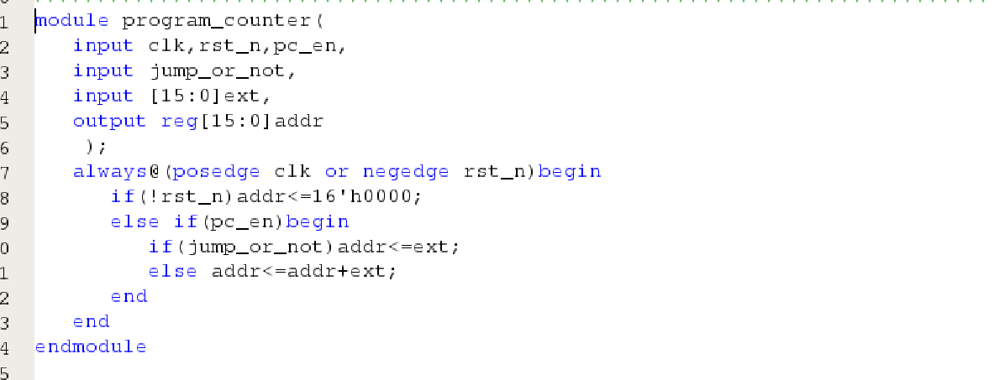

1. 256*16 Memory

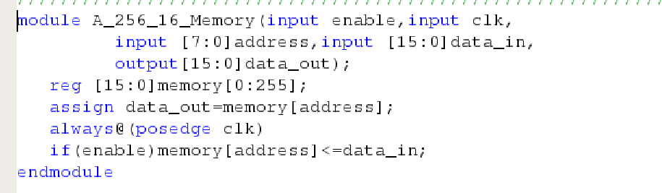

1. Register File + ALU

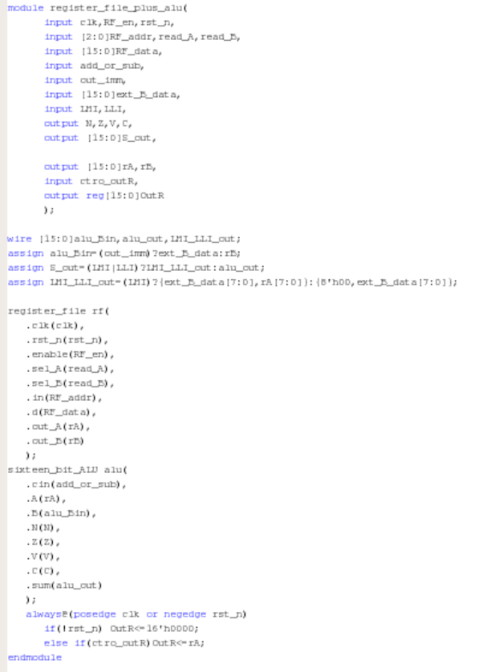

1. Eight Register File

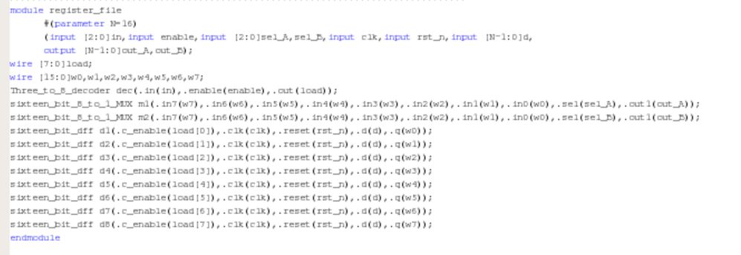

1. ALU

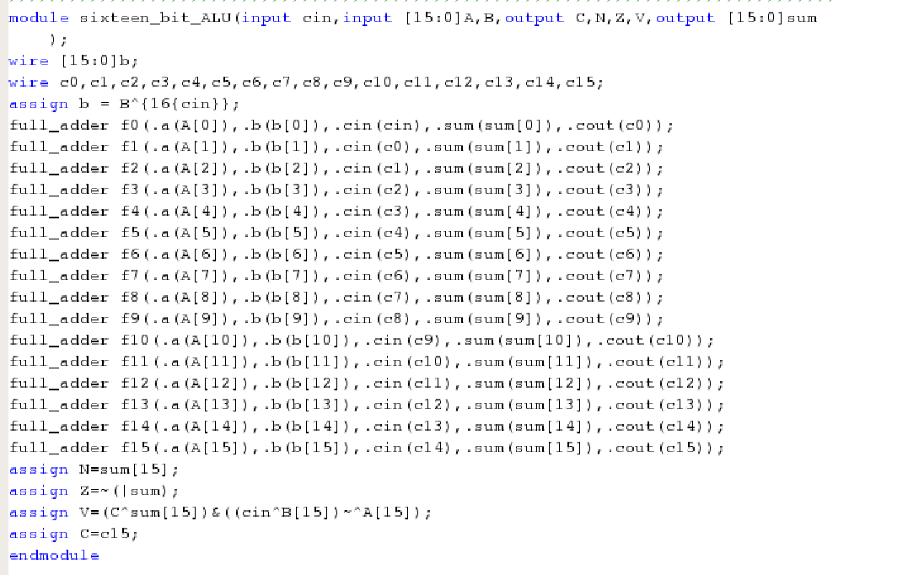

1. Full Adder

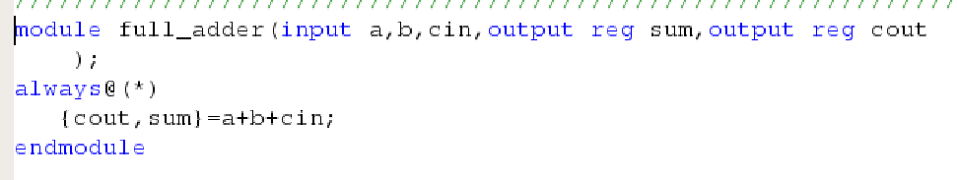

1. Decoder

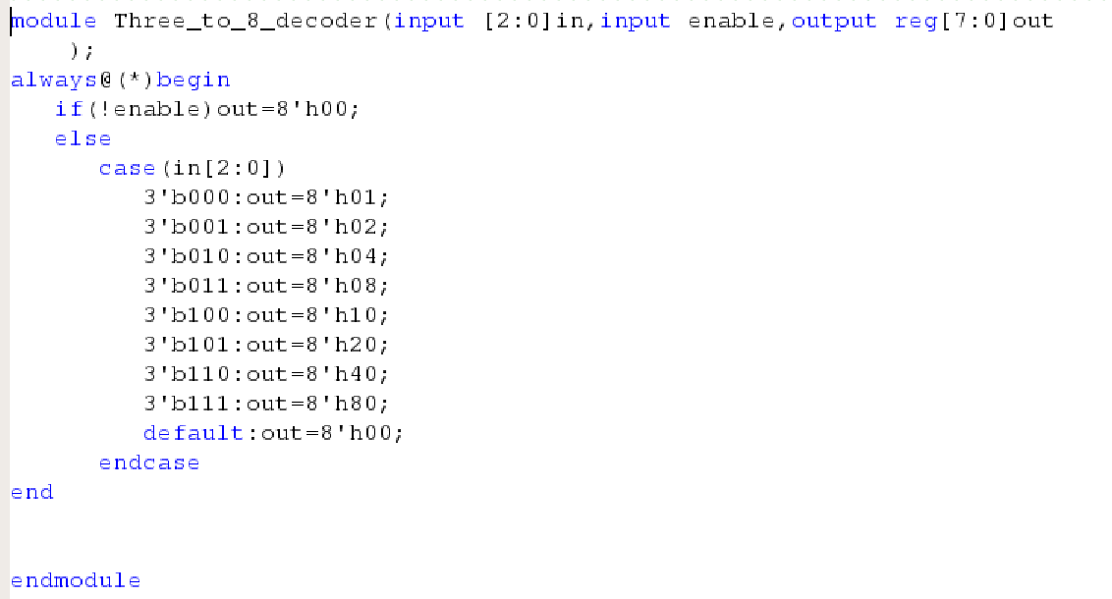

1. 16bits 8to1 Multiplexer

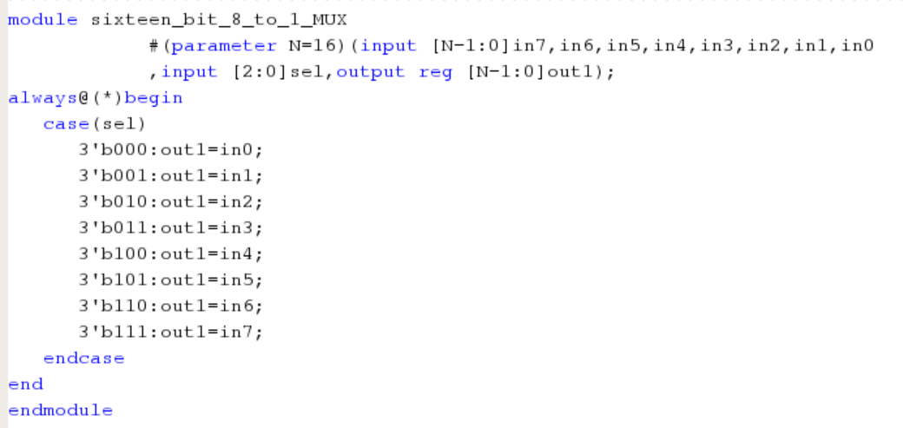

1. 16bits D-Flip Flop

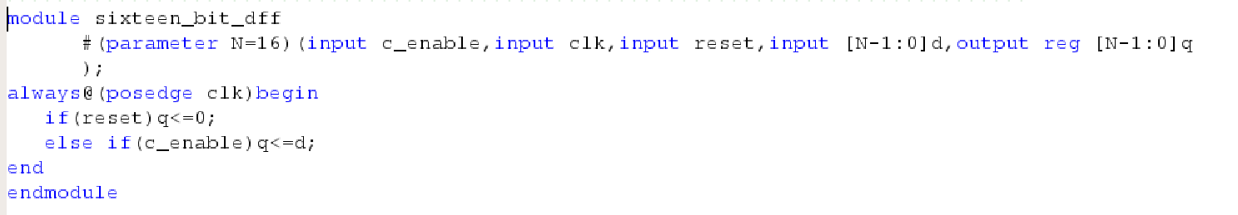

Verification

1. CPU

Test Bench

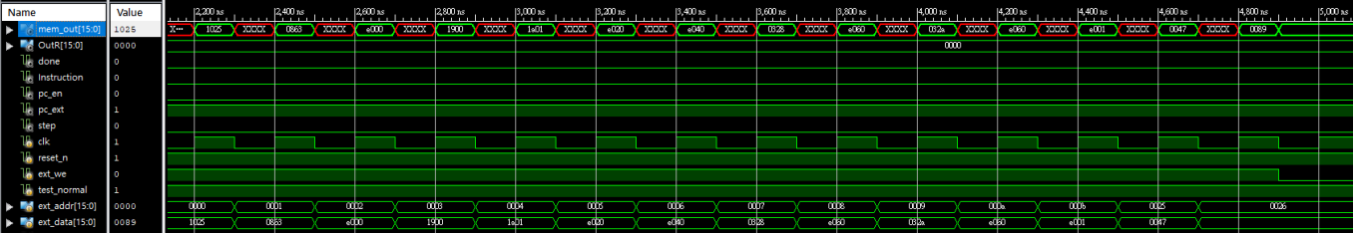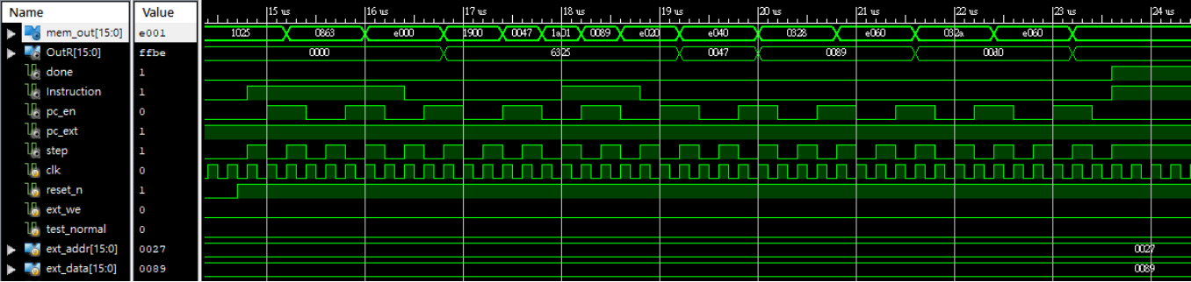

Post-Route

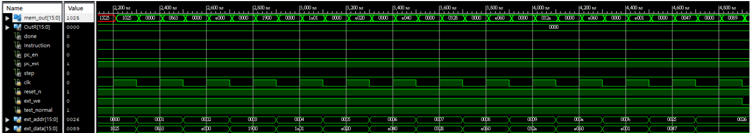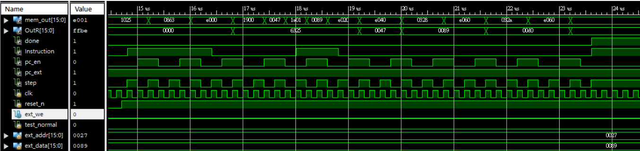

1. Controller

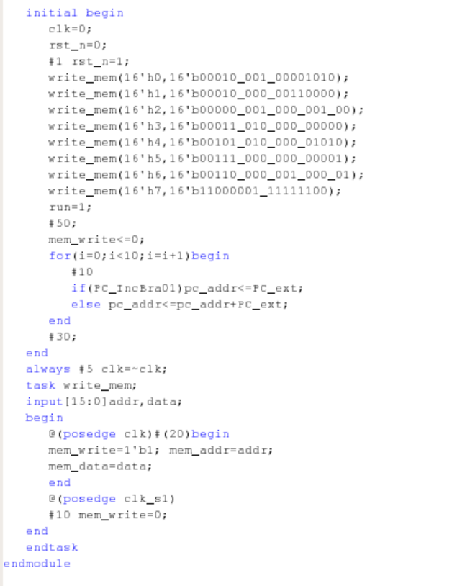

Test Bench

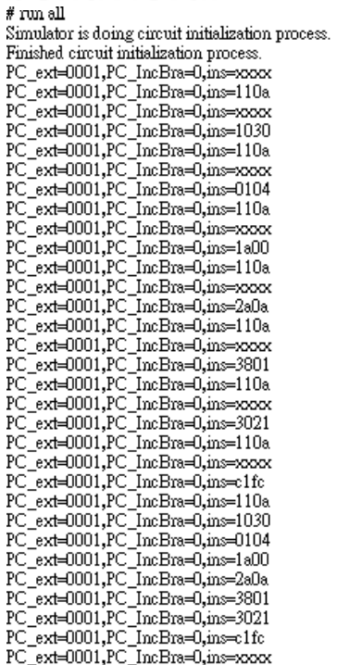

Post-Route

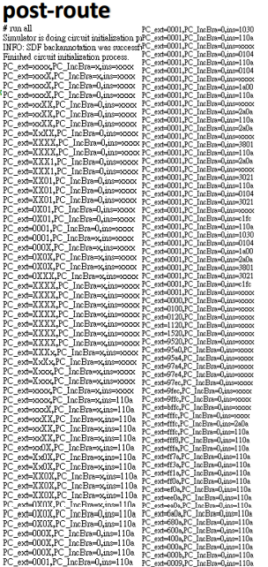

1. Datapath

Test Bench

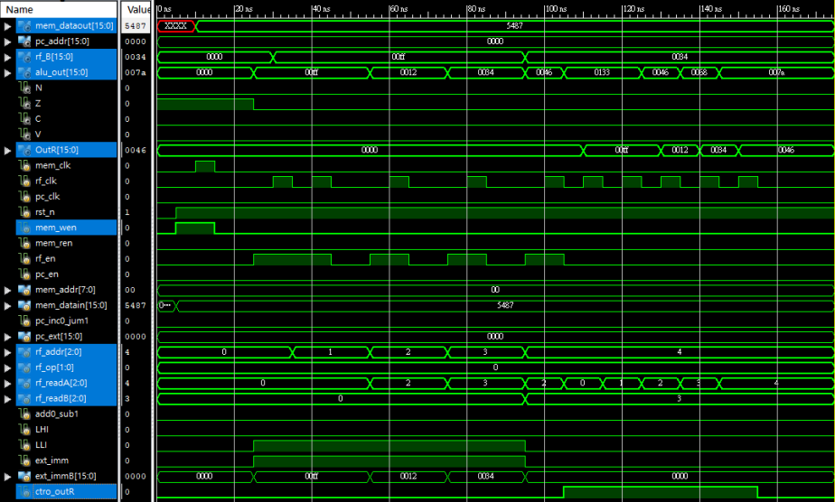

Post-Route

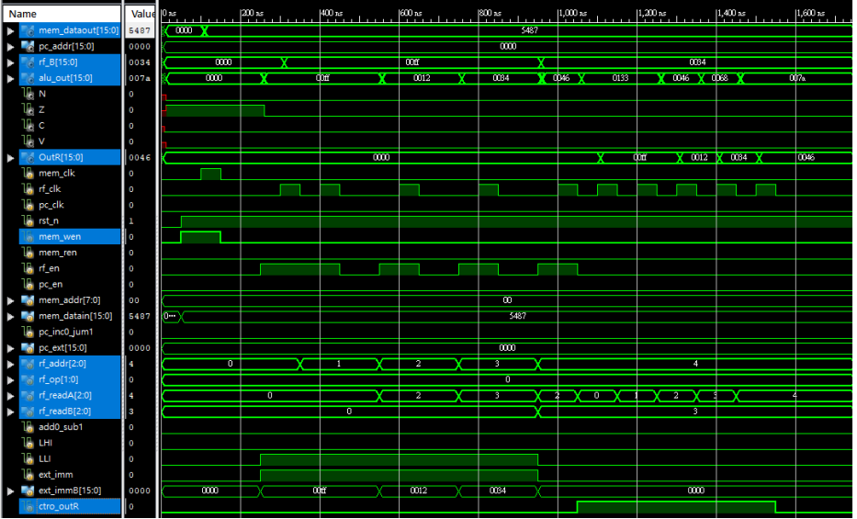

1. Instruction Decoder

Test Bench

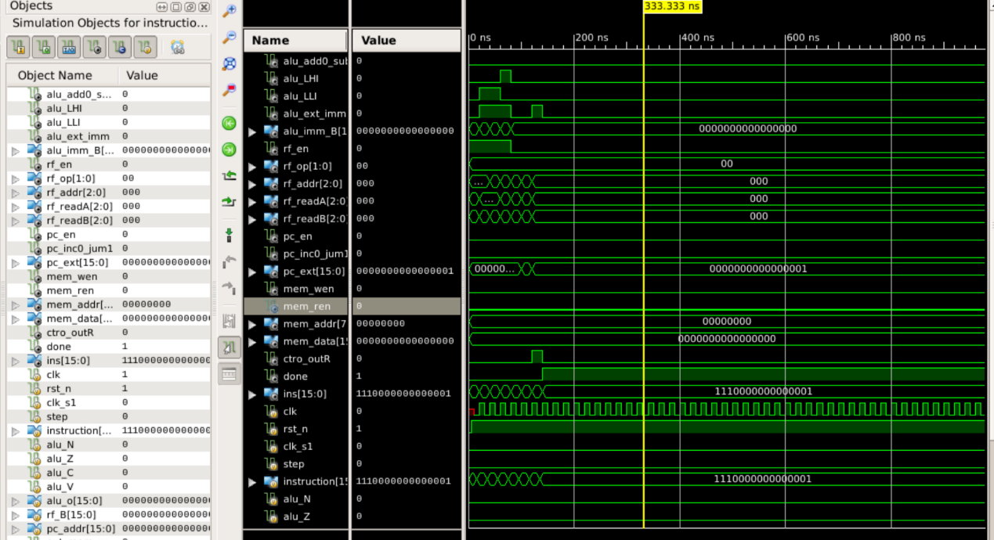

Post-Route

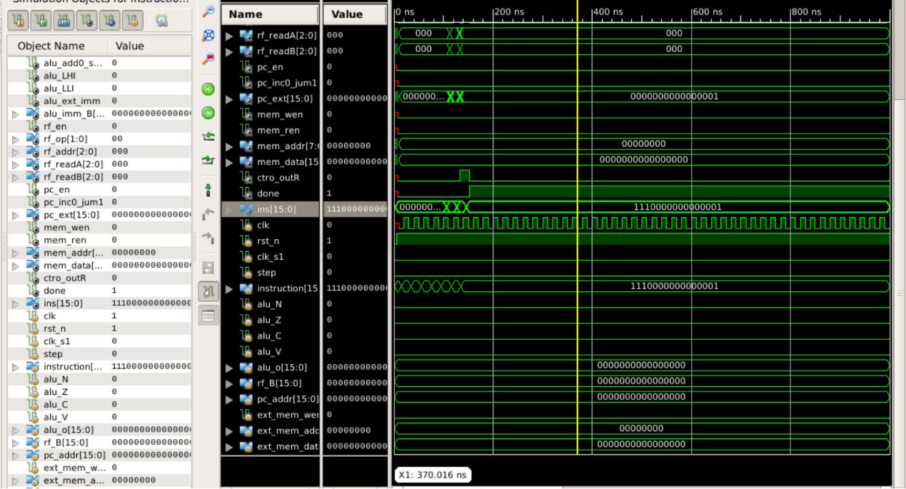

1. Timing Generator

Test Bench

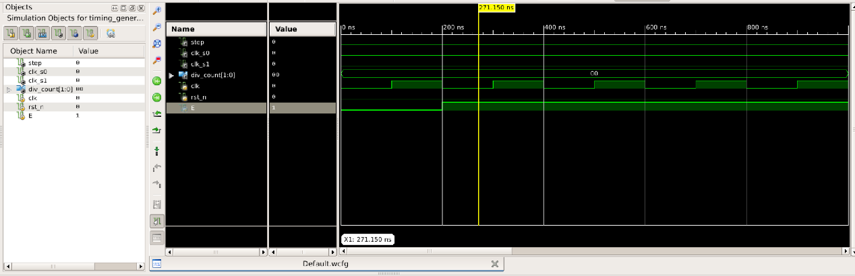

Post-Route

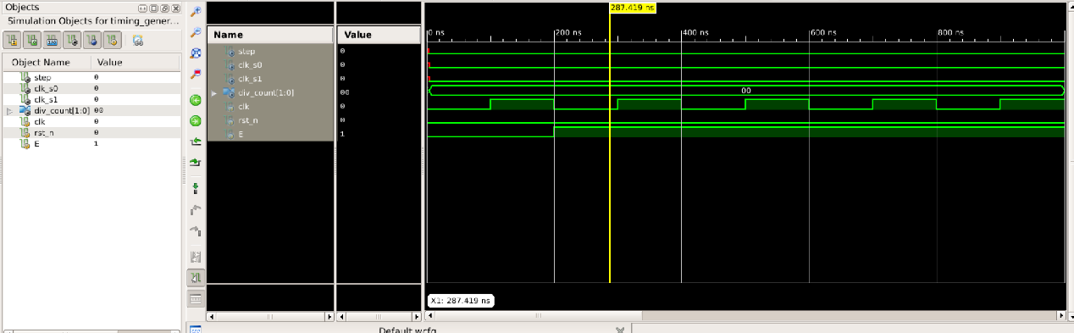

1. Program Counter

Test Bench

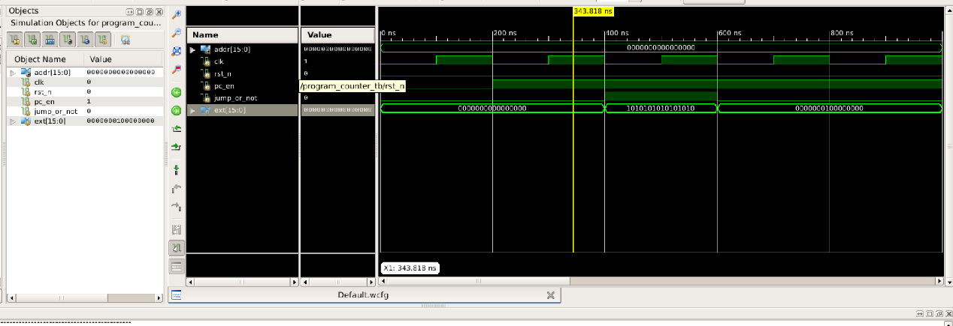

Post-Route

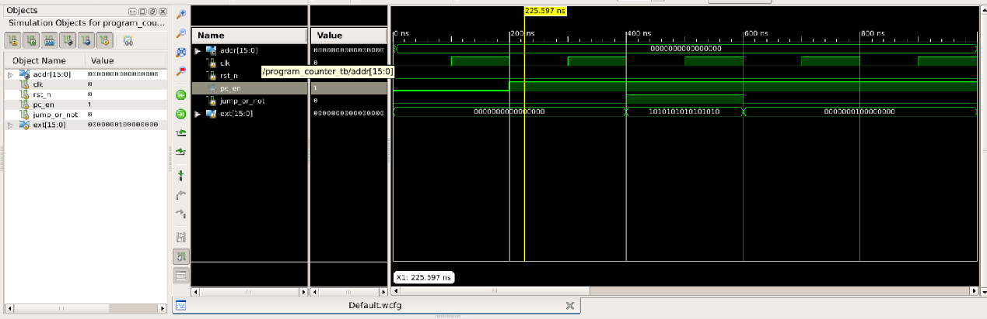

1. 256*16 Memory

Test Bench

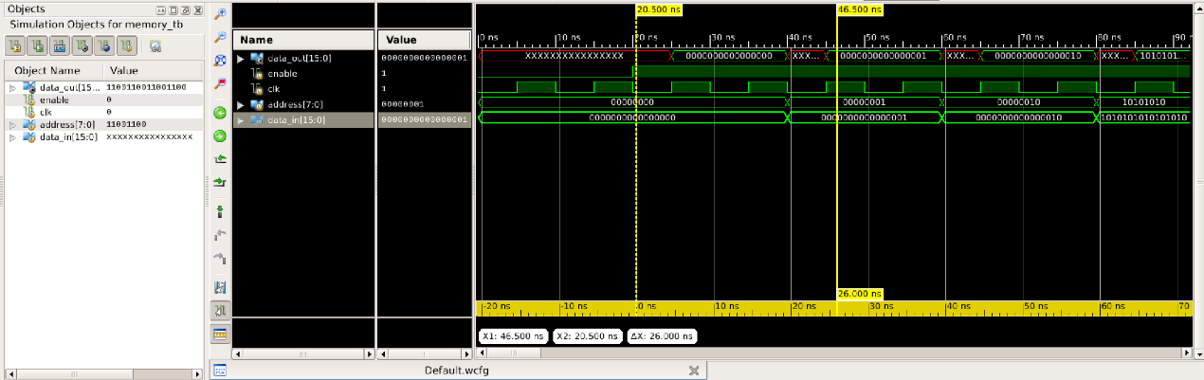

Post-Route

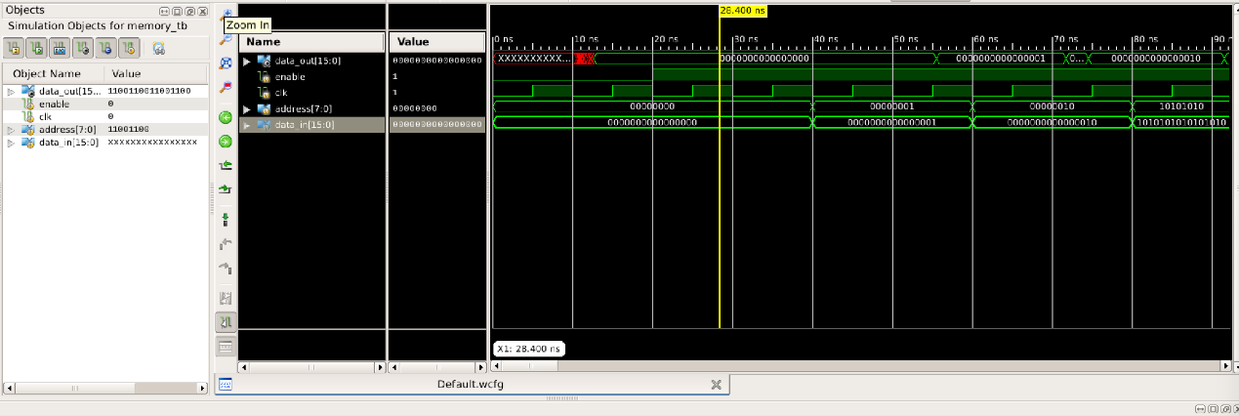

1. Register File + ALU

Test Bench

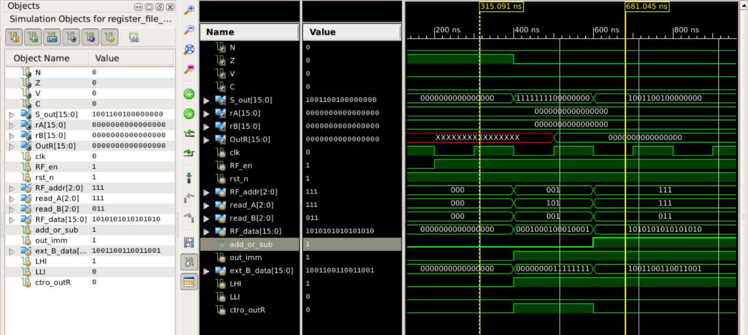

Post-Route

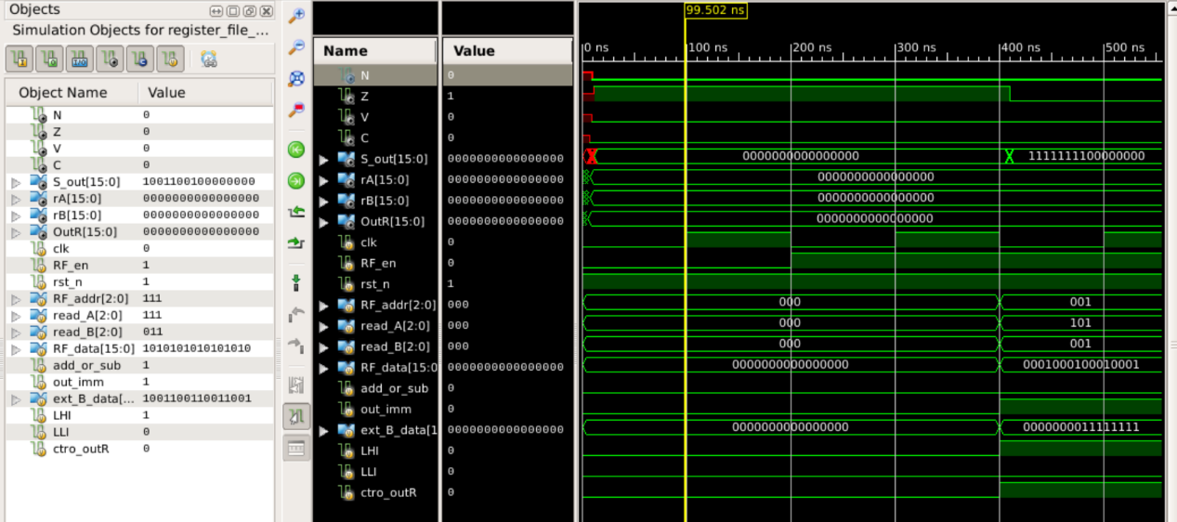

1. Register File

Test Bench

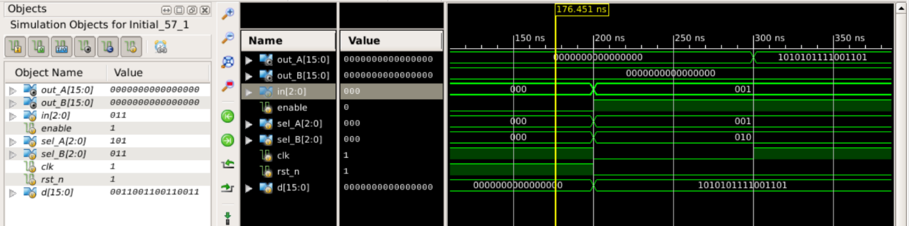

Post-Route

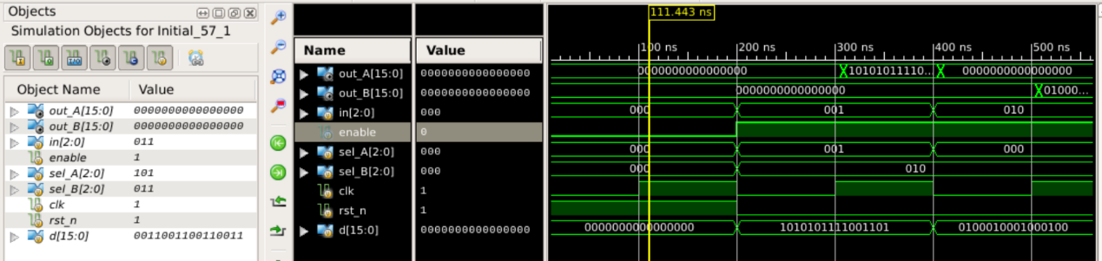

1. ALU

Test Bench

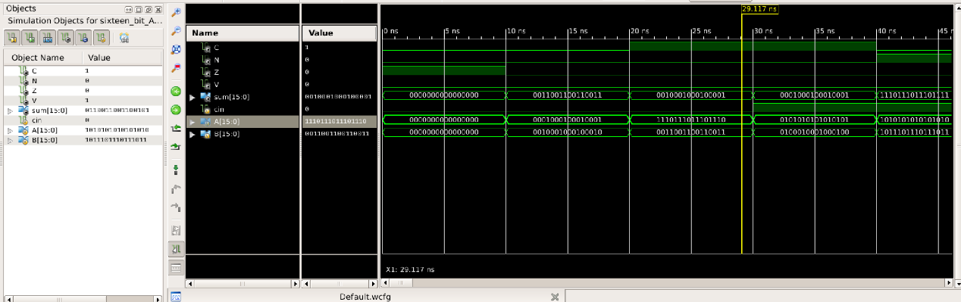

Post-Route

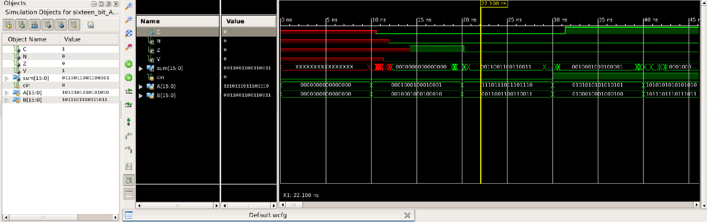

1. Full Adder

Test Bench

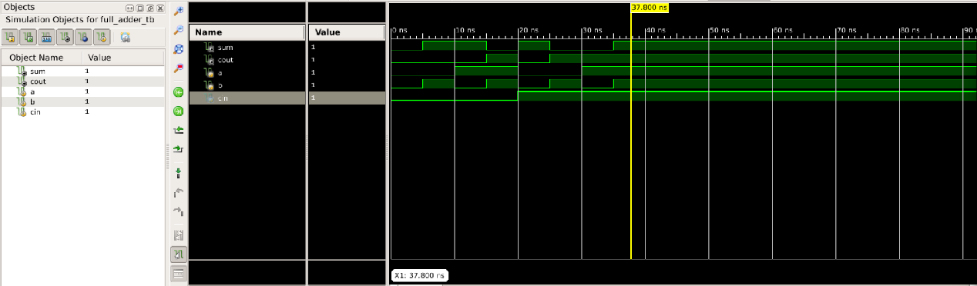

Post-Route

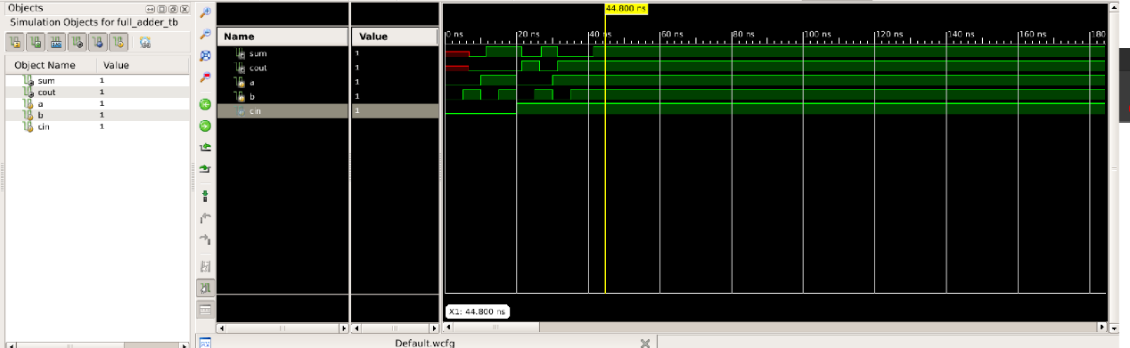

1. 3to8 Decoder

Test Bench

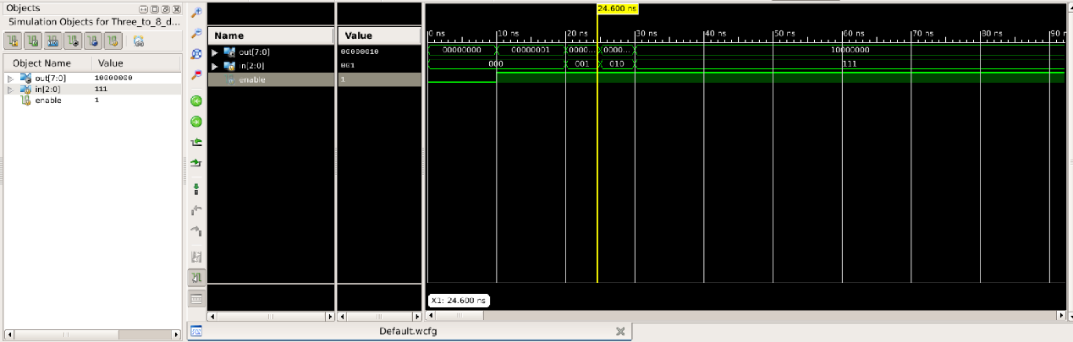

Post-Route

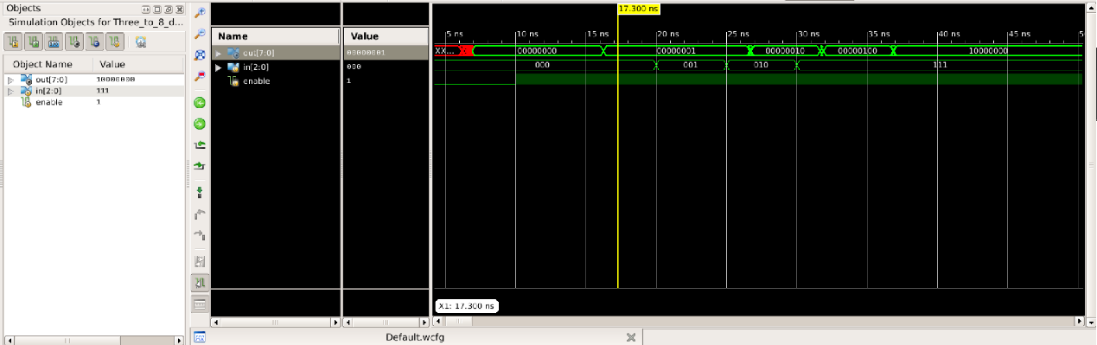

1. 8to1 MUX

Test Bench

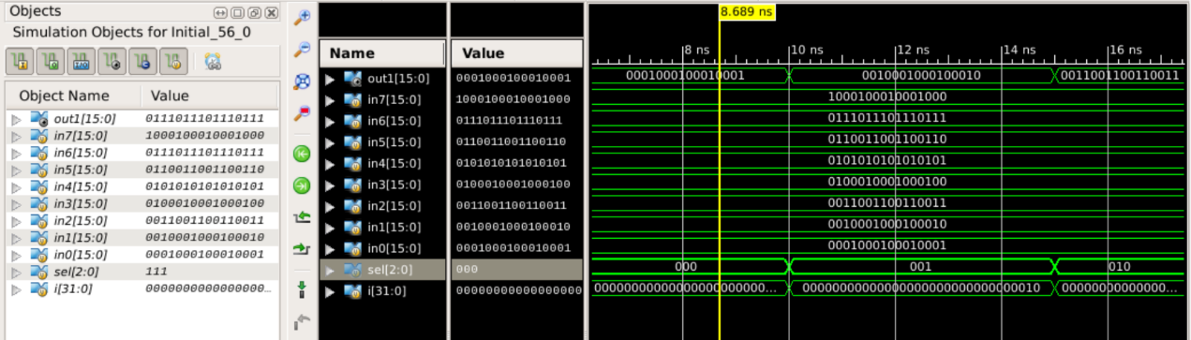

Post-Route



1. D-Flip Flop 16bits

Test Bench

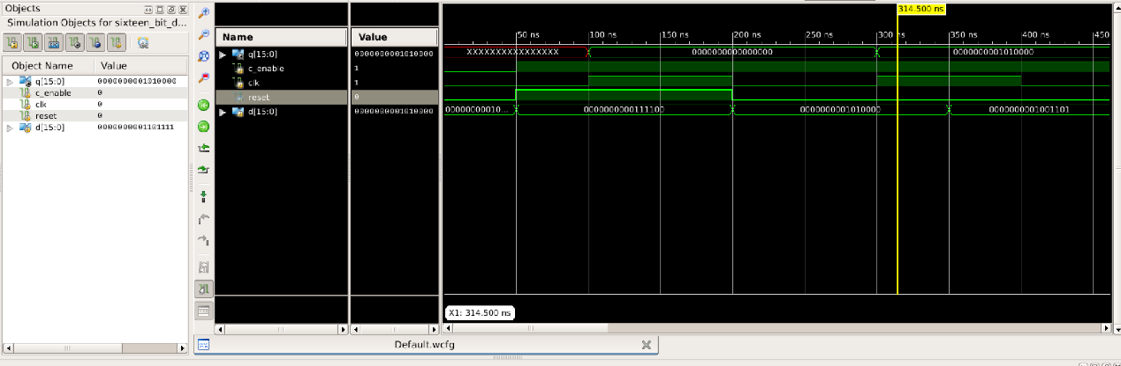

Post-Route

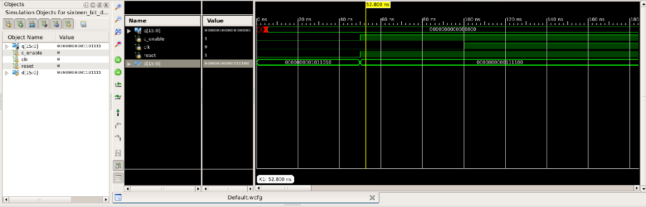

1.Find the minimum and maximum from two numbers in memory

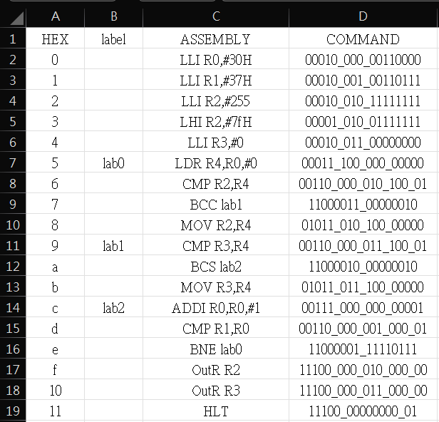

Test Bench

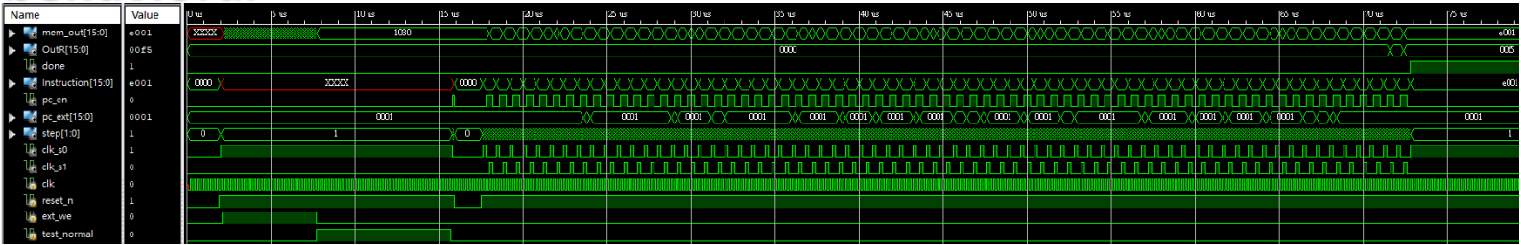

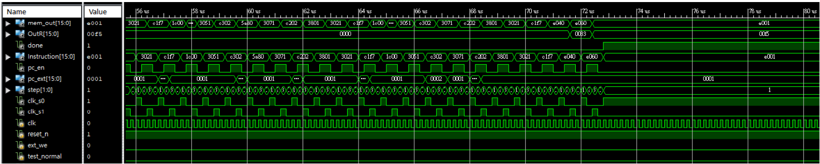

Post-Route

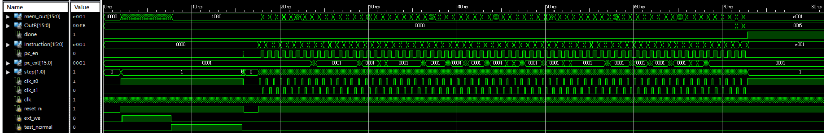

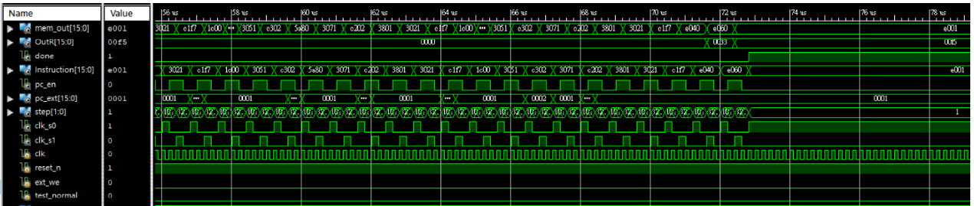

2. Add two numbers in memory and store the result in memory location

write_mem(16'h0,16'b00010_000_00110000 ) ;//LLI R0,#30H

write_mem(16'h1,16'b00011_011_000_00000 ) ; //LDR R3,R0,#0

write_mem(16'h2,16'b00011_100_000_00001 ) ; //LDR R4,R0,#1

write_mem(16'h3,16’b00000_010_011_100_00 ) ; //ADD R2,R3,R4 write_mem(16'h4,16'b00101_010_000_00010 ) ; //STR R4,R0,#0

write_mem(16'h5,16'b00011_001_000_00010 ) ; //LDR R1,R0,#2

write_mem(16'h6,16'b11100_000_001_000_00 ) ; //OutR R1

write_mem(16'h7,16'b11100_000000000_01 ) ; //HLT

Test Bench

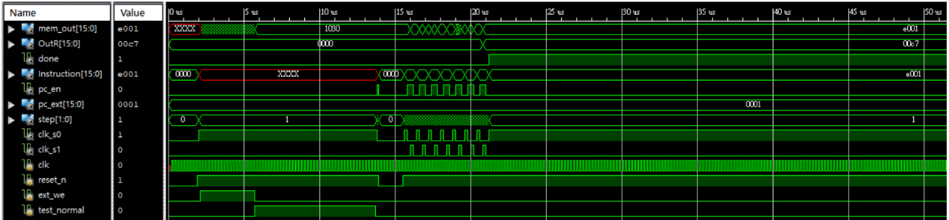

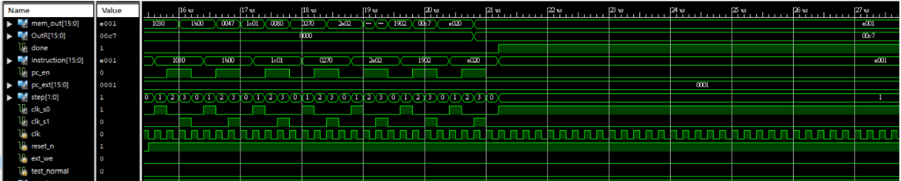

Post-Route

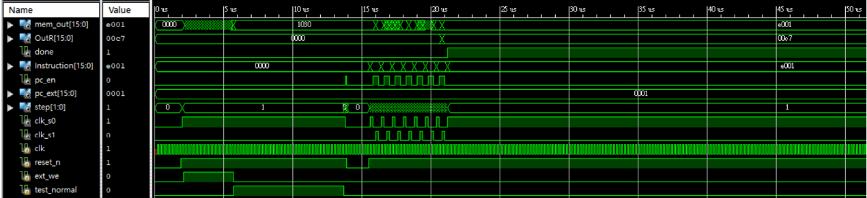

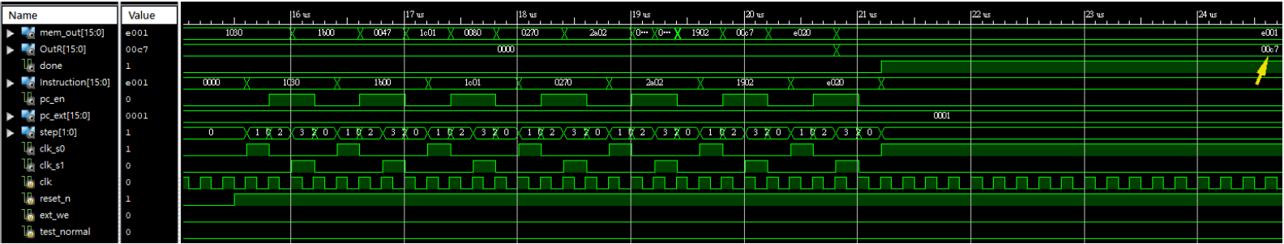

3. Add ten numbers in consecutive memory locations

write_mem(16'h0,16'b00010_000_00110000 ) ;//LLI R0,#30H

write_mem(16'h1,16'b00010_010_00111001 ) ;//LLI R2,#39H

write_mem(16'h2,16'b00011_001_000_00000 ) ; //LDR R1,R0,#0

write_mem(16'h3,16’b00111_001_001_011_00 ) ; //ADDI R0,R0,#1

write_mem(16'h4,16'b00011_011_000_00000 ) ; //LDR R3,R0,#0 write_mem(16'h5,16’b00000_001_001_011_00 ) ; //ADD R1,R1,R3

write_mem(16'h6,16'b00110_000_010_000_01 ) ; //CMP R2,R0

write_mem(16'h7,16'b11000001_11110111 ) ; //BNE lab0

write_mem(16'h8,16'b11100_000_001_000_00 ) ; //OutR R1

write_mem(16'h9,16'b11100_000000000_01 ) ; //HLT

Test Bench

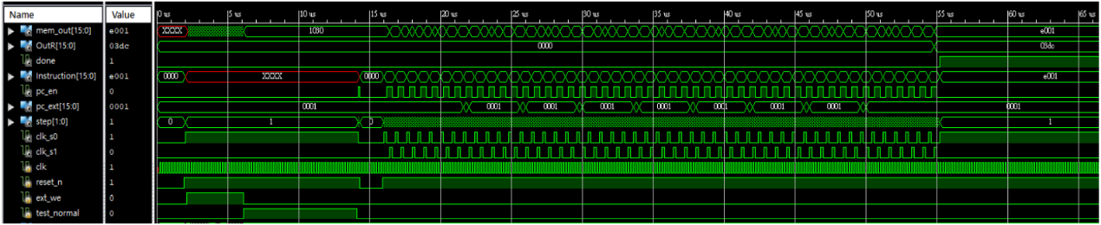

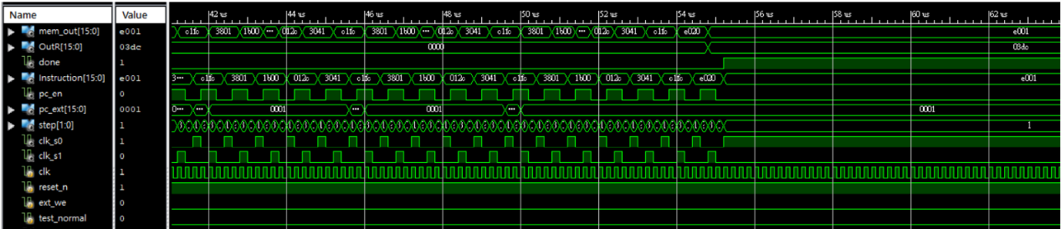

Post-Route

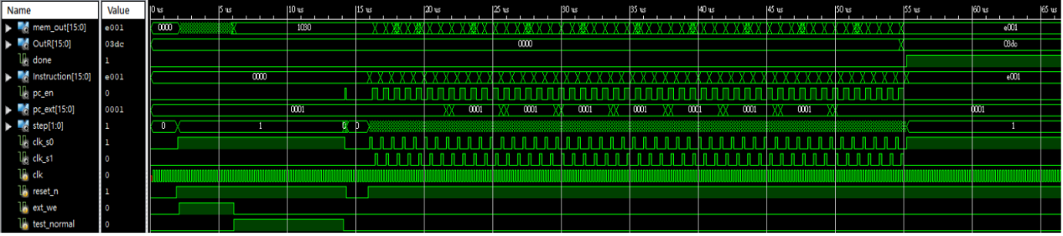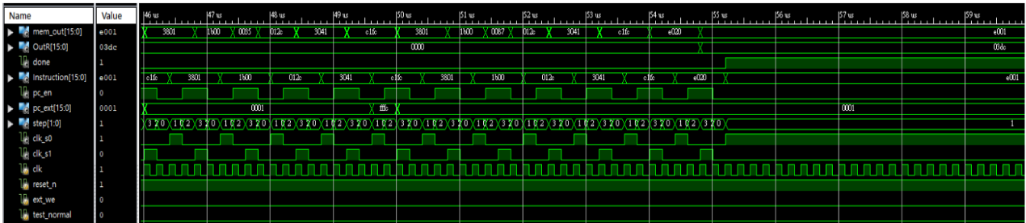

4.Move a memory block of N words from one place to another

write_mem(16'h0,16'b00010_000_00110000 ) ;//LLI R0,#30H

write_mem(16'h1,16'b00010_010_00111001 ) ;//LLI R2,#39H

write_mem(16'h2,16'b00011_001_000_00000 ) ; //LDR R1,R0,#0

write_mem(16'h3,16’b00111_001_001_011_00 ) ; //ADDI R0,R0,#1

write_mem(16'h4,16'b00011_011_000_00000 ) ; //LDR R3,R0,#0 write_mem(16'h5,16’b00000_001_001_011_00 ) ; //ADD R1,R1,R3

write_mem(16'h6,16'b00110_000_010_000_01 ) ; //CMP R2,R0

write_mem(16'h7,16'b11000001_11110111 ) ; //BNE lab0

write_mem(16'h8,16'b11100_000_001_000_00 ) ; //OutR R1

write_mem(16'h9,16'b11100_000000000_01 ) ; //HLT

Test Bench

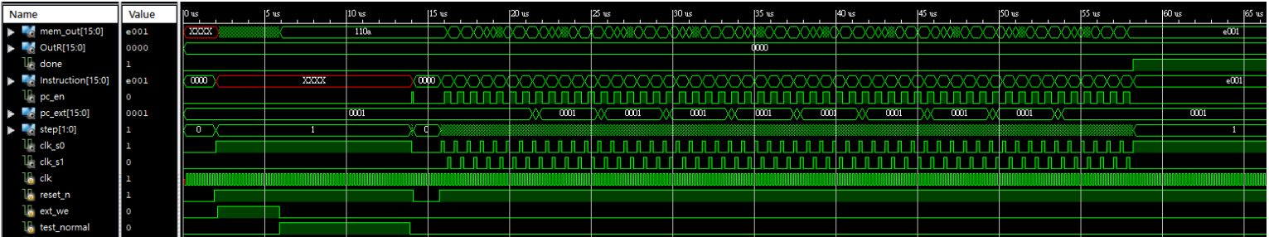

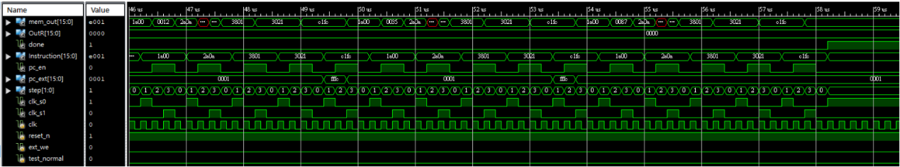

Post-Route

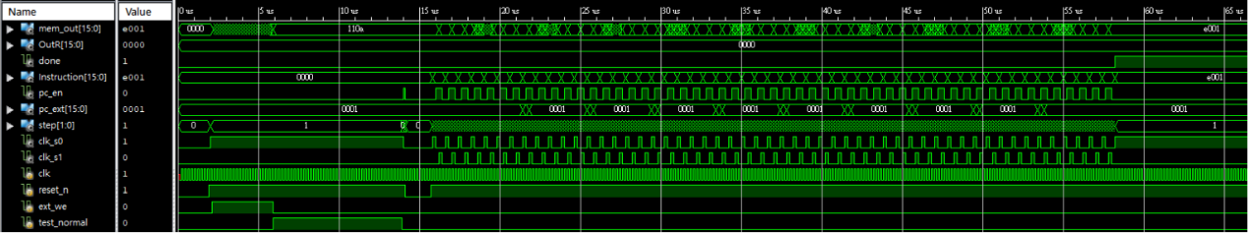

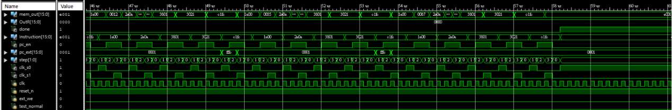

Hardware Cost

Total number of LUTs 340

Total number of FFs 179

16-bits RISC CPU hardware cost

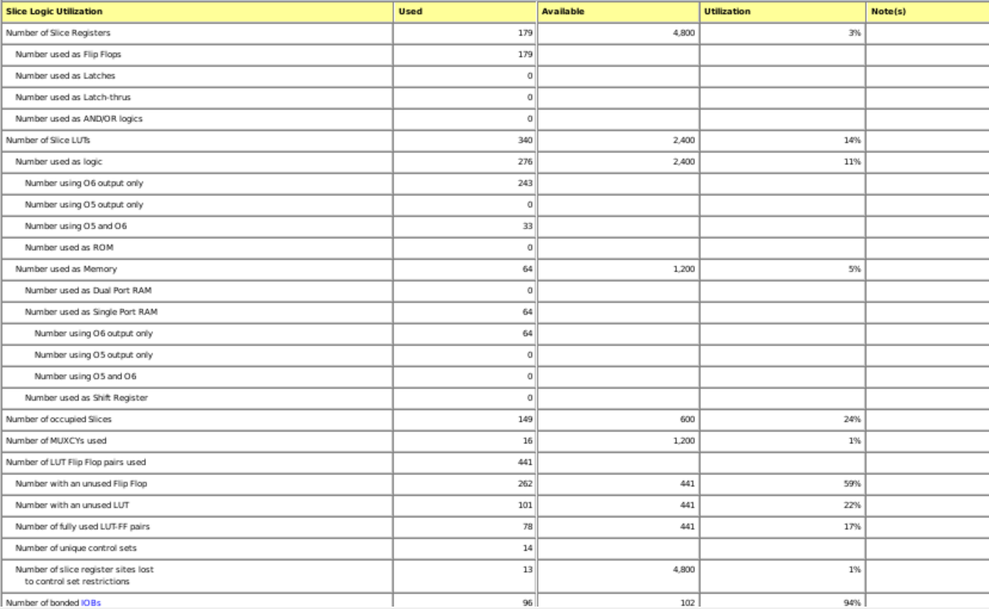

Discussion

1. Design Entry

相較於期中的schematic，期末寫verilog相對來的簡單些，在做更大bit數的module，也方便很多，不需要重複拉很多相同的小模塊，最重要的是我期中有許多module 的Post-Route整個炸掉，那時候沒有特別注意到這個部分，況且當時對時序的概念也很生疏，為了避免像期中一樣，這次有特別留意，最終有跑出正確的結果。

1. Schematic & HDL

從這堂課中，學到了老師上課常說的，在寫verilog時，心裡就要有想法做出來的電路大概長怎樣，透過期中和期末的作業讓我對這塊領域又有更深入的了解，但是我的Hardware Cost其實是不太一樣的，這讓我意識到我一定還有有些地方沒搞很清楚，這也是我未來努力的目標與增進的方向。

1. 心得

一開始我對硬體描述語言的撰寫能力其實是很薄弱的，平常只有寫寫HBLbits和大學修過數位系統導論實驗課而已，但是經過這學期的努力，我感覺到我有所成長，因此在此非常感謝林教授本學期細心的教導。